**PROJECT REPORT**

**PROJECT TITLE:** STREAMLINING TICKET ASSIGNMENT FOR EFFICIENT SUPPORT OPERATIONS

**TEAM ID:** NM2025TMID19267

**TEAM LEADER:** PAVITHRA R

**TEAM MEMBER**: DHANUSRI G

**TEAM MEMBER:** YUVASHREE E

**TEAM MEMBER:** KAVIYA R

**Problem Statement:**

In many organizations, customer support teams receive a large number of help tickets every day. If these tickets are not assigned to the right person quickly, it can lead to delays, poor customer satisfaction, and stress for support agents. This project focuses on creating a simple and smart system to assign tickets to the right support agent based on their skills, workload, and availability. By improving how tickets are assigned, we can make the support process faster, smoother, and more efficient.

**Objective:**

1. To understand the problems in the current ticket assignment process.

2. To design a system that assigns tickets automatically and fairly.

3. To reduce the time customers wait for their issues to be solved.

4. To make sure tickets are given to the right agents based on their skills.

5. To improve teamwork and reduce extra work for support staff.

6. To increase overall customer satisfaction through faster service.

**Skills:**

Users, Groups, Roles, Table, Assign roles & users to groups, Assign role to table, create ACL, Flow.

**TASK INITIATION**

# Milestone 1: Users

**Activity 1: Create Users**

1. Open service now
2. Click on All >> search for Users
3. Select user under system security
4. Click on new
5. 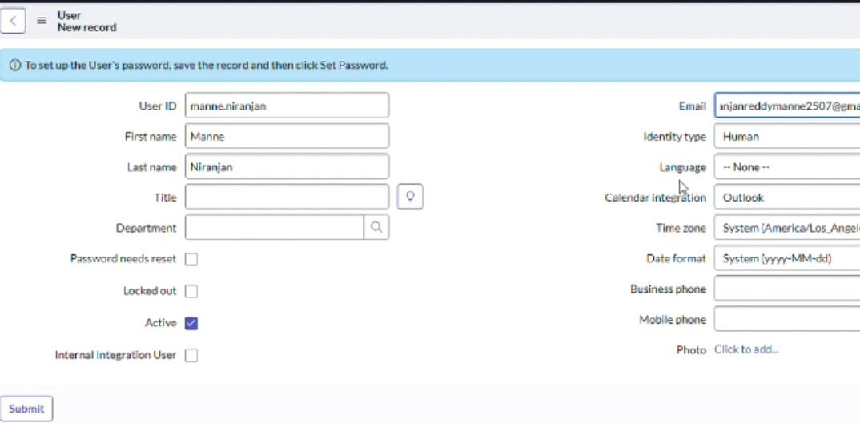Fill the following details to create a new user
6. Click on submit Create one more user.
7. Create another user with the following details

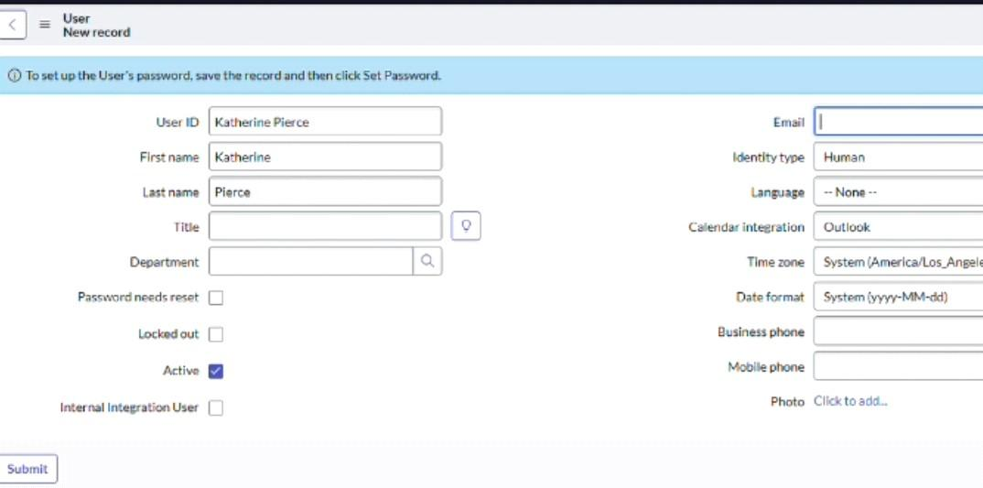

1. Click on submit

# Milestone 2: Groups

**Activity 1: Create Group**

**1.**Open service now

2.Click on All >> search for groups

3.Select group under system security

4.Click on new

5.Fill the following details to create a new group

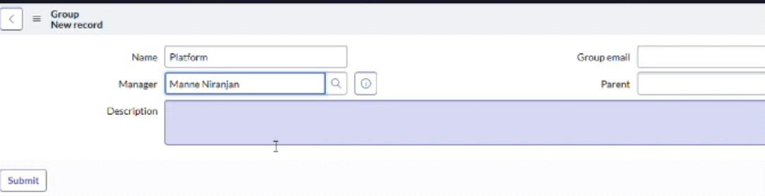

1. Click on submit.

# Milestone 3: Roles

**Activity 1: Create Roles**

* + 1. Open service now
    2. Click on All >> search for roles
    3. Select roles under system security
    4. Click on new
    5. Fill the following details to create a new role

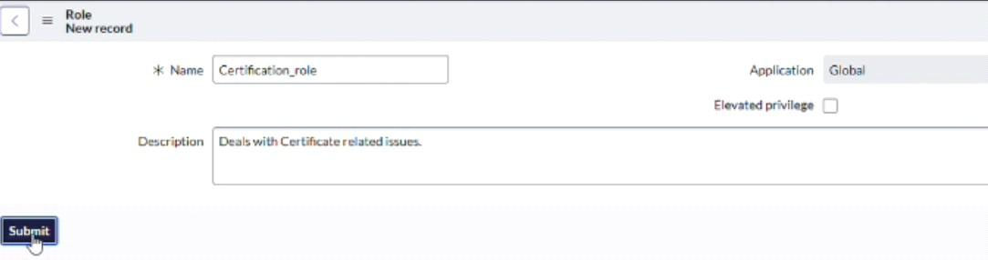

* + 1. Click on submit Create one more role
    2. Create another role with the following details

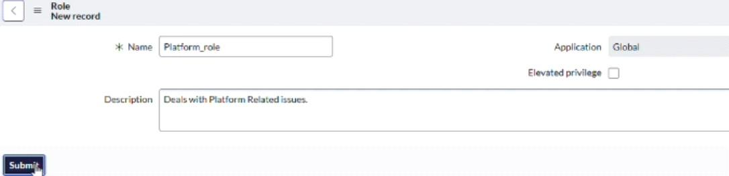

* + 1. Click on submit.

# Milestone 4: Table

**Activity 1: Create Table**

* + - 1. Open service now
      2. Click on All >> search for table
      3. Select tables under system security
      4. Click on new
      5. Fill the following details to create a new table Label: Operation related

Checked the boxes create modules & create mobile module

* + - 1. Under new menu name: Operations related
      2. 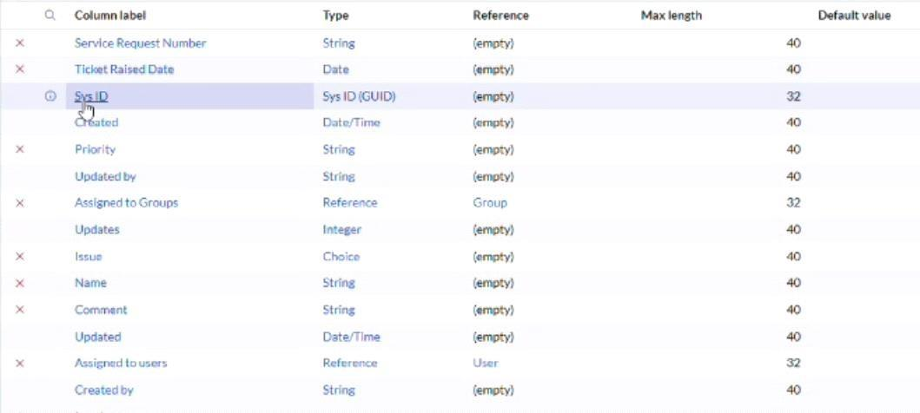Under table columns give the columns
      3. Click on submit

Create choices for issue filed by using form design Choices are

* + - * 1. Unable to login to platform
        2. 404 error
        3. Regarding certificate
        4. Regarding user expired

# Milestone 5: Assign Roles & Users to Group

**Activity 1: Assign Roles & User to Certificate Group**

1. Open service now
2. Click on All >> search for tables
3. Select tables under system definition
4. Select the certificate group
5. Under group members
6. Click on edit
7. Select Katherine pierce and save
8. Click on roles
9. Select certification_ role and save

# Activity 2: Assign Roles & User to Platform Group

1. Open service now
2. Click on All >> search for tables
3. Select tables under system definition
4. Select the platform group
5. Under group members
6. Click on edit
7. Select Manne Niranjan and save
8. Click on roles
9. Select platform_ role and save

# Milestone 6: Assign Roles to Table

1. Open service now
2. Click on All >> search for tables
3. Select operations related table
4. Click on the application access
5. Click on u_ operations_ related read operation
6. Click on the profile on top right side
7. Click on elevate role
8. Click on security admin and click on update
9. Under requires role
10. Double click on insert a new row
11. Give platform role
12. And add certificate role
13. Click on update

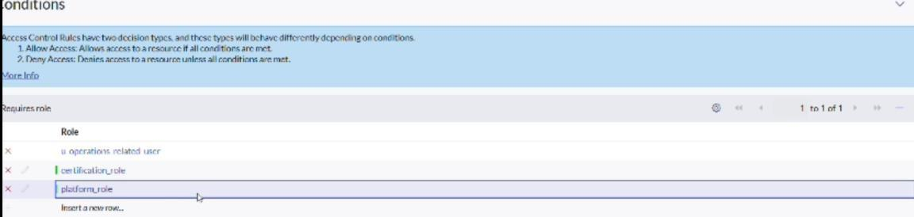

# Milestone 7: Create ACL

1. Open service now
2. Click on All >> search for tables
3. Select Access Control (ACL) under system security
4. Click on new
5. Fill the following details to create a new ACL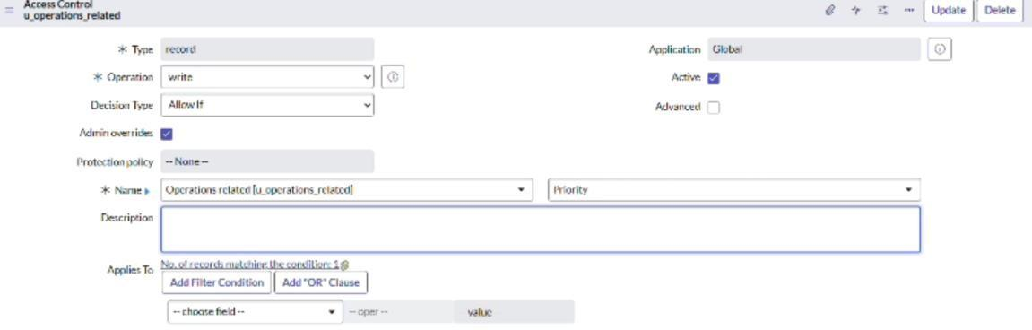
6. Scroll down under requires role
7. Double click on insert a new row
8. Give admin role
9. Click on submit
10. Similiarly create 4acl for the following fields



# Milestone 7: Flow

**Activity 1: Create a flow to assign operation ticket to group**

1. Open service now
2. Click on All >> search for tables

3.Click on flow designer under process automation

4.After opening flow designer click on new and select flow

5.Under flow properties Give Flow Name as

“Regarding Certificate”

6. Application should be global

7.Select Run user as “System user” from that choice

8.Click on submit.

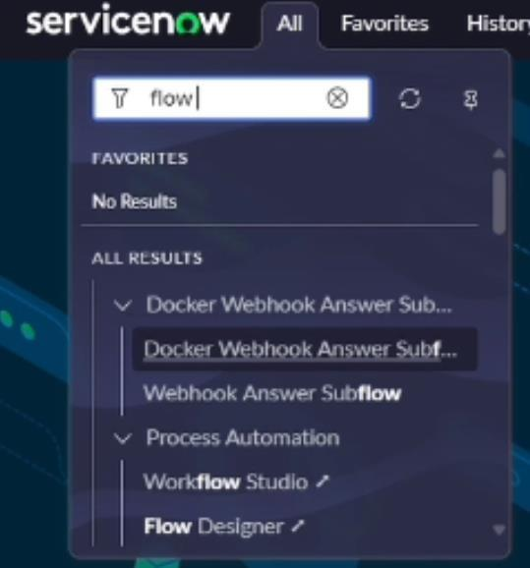

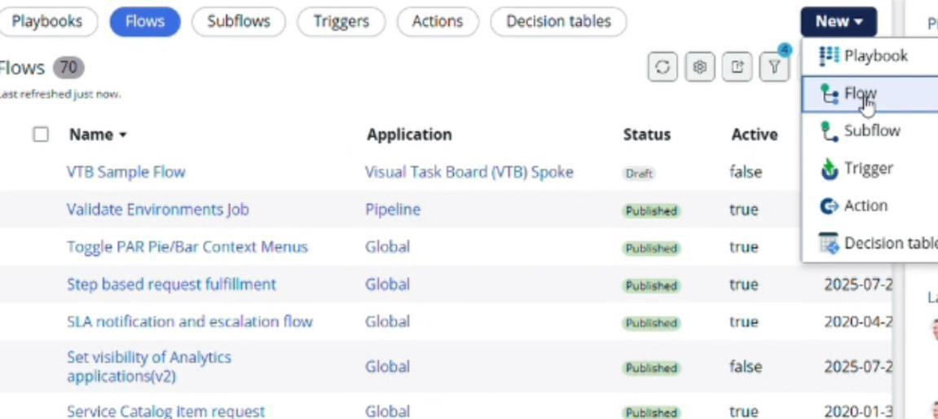

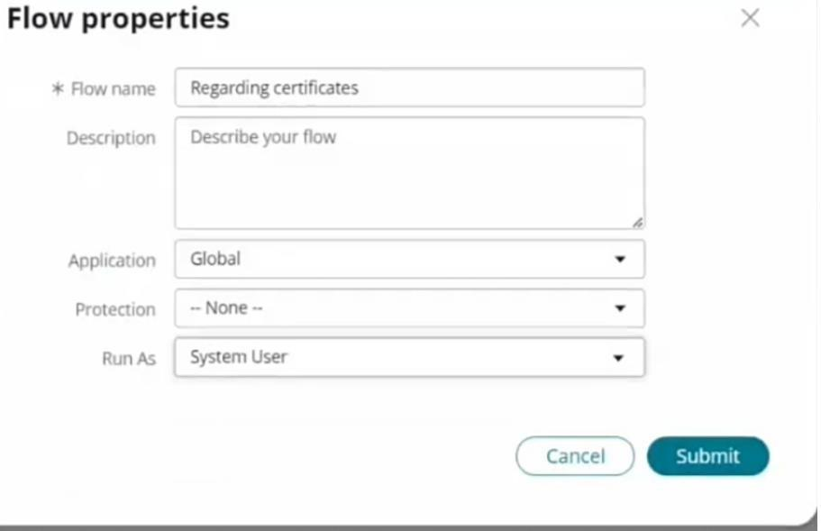

1. Click on add a trigger
2. Select the trigger in that search for "create or update a record" and select that.
3. Give the table name as "Operation related"
4. Give the condition as Field: issue Operation: is

Value: Regrading Certificate

1. After that click on Done
2. Now under action
3. Click on add an action
4. Select action in that search for "Update Record"
5. In Record field drag the fields from the data navigation from left side
6. Table will be auto assigned after that
7. Give the field as "Assigned to group"
8. Give value as "Certificates"
9. Click on Done.
10. Click on save to save the Flow.
11. Click on Activate.

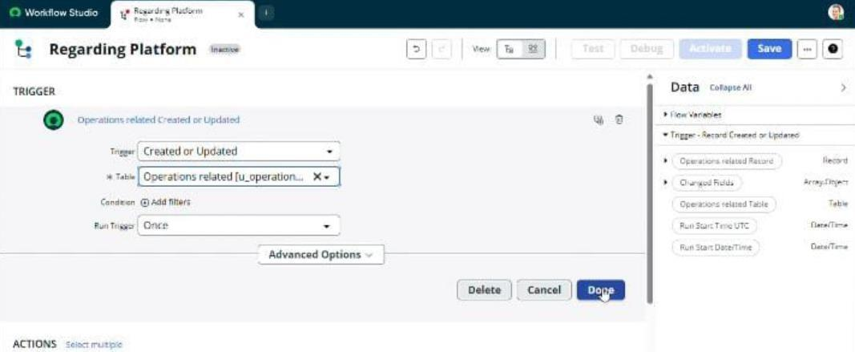

# Activity 2: Create A Flow To Assign Operations Ticket To Platform Group

1. Open service now
2. Click on All >> search for flow designer
3. Click on flow designer under process automation
4. After opening flow designer click on new and select flow
5. Under flow properties Give flow name as "Regarding platform"
6. Application should be Global
7. Select Run user as "System user "from that choice
8. Click on submit

**THEN:**

1. Click on Add a trigger
2. Select the trigger in that search for "create or update a record" and select that
3. Give the table name as "Operation related"
4. Give the condition as:

Field: issue

Operation: is

Value: Unable to login to platform

1. Click on new criteria

Field: issue

Operation: is

Value: 404 Error

1. Click on new criteria

Field: issue

Operation: is

Value: Regrading user expired

1. After that click on done
2. Now under actions
3. Click on add an action
4. Select action in that search for "Update Record"
5. In record field drag that fields from the data navigation from left side
6. Table will be auto assigned after that
7. Give the field as "Assigned to group"
8. Give value as "Platform"
9. Click on Done
10. Click on save to save the flow
11. Click on activate

# Conclusion:

Streamlining ticket assignment helps support teams work faster and smarter. By reducing manual effort and assigning tickets automatically to the right person, the process becomes smoother and more accurate. This not only saves time for the team but also improves customer satisfaction. In the end, efficient ticket assignment builds a strong support system where problems are solved quickly and effectively.